Ideation Phase
Brainstorm & Idea Prioritization
Date | 12 October 2026
Team ID | SWUID2026403326
Project Name | IMovies - Online Movie, Event & Entertainment Ticket Booking System
Maximum Marks | 4 Marks
Brainstorm & Idea Prioritization:
A brainstorming session gives the team room to put every idea on the table before any of them is judged. The focus is on generating many ideas, building on one another’s suggestions and only then deciding which ones deserve to be built. For IMovies, the team used this approach to turn the problems found in the SRS into a ranked list of features and a clear build order.
Reference: https://www.mural.co/templates/brainstorm-and-idea-prioritization
Step-1: Team Gathering, Collaboration and Select the Problem Statement
The team agreed on a few ground rules before starting:
- Defer judgment: no idea is rejected while ideas are being collected.
- Go for quantity first; refine quality afterwards.
- Build on other people’s ideas instead of replacing them.
- Stay tied to the problem statements and the SRS modules.
Selected problem statement (How might we...): How might we let customers find a show, pick the exact seats they want and pay without conflicts or failed bookings, while giving cinemas, organizers and admins simple tools to run shows, events, refunds and reports?
Input | Source
Problems to solve | PS-1 to PS-6 from the Define the Problem Statements document (seat conflicts, scattered listings, unclear refunds, no live occupancy, event overselling, no admin dashboard)
Scope reference | Software Requirements Specification: modules for authentication, movies, cinemas, seats, booking, payment, events, notifications, admin and analytics
Team format | Four members, each taking one area: discovery, booking and payment, cinemas and events, admin and future ideas
Step-2: Brainstorm, Idea Listing and Grouping
Each team member silently wrote down five ideas for their area, then shared them with the group. The board below shows all 20 ideas collected.
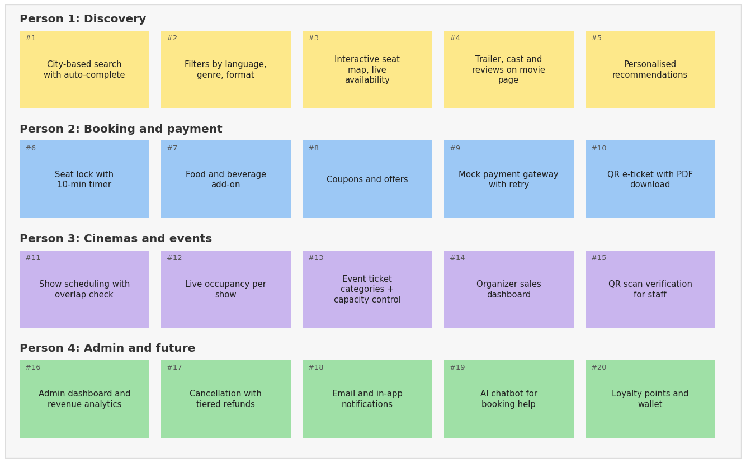
Related ideas were then grouped into six themes:
Theme | Ideas | Count
A. Discovery and search | #1 City-based search with auto-complete; #2 Filters by language, genre, format; #4 Trailer, cast and reviews on movie page; #5 Personalised recommendations | 4
B. Seat selection and checkout | #3 Interactive seat map, live availability; #6 Seat lock with 10-min timer; #7 Food and beverage add-on; #8 Coupons and offers; #9 Mock payment gateway with retry | 5
C. Tickets and after-booking | #10 QR e-ticket with PDF download; #17 Cancellation with tiered refunds; #18 Email and in-app notifications | 3
D. Show and event operations | #11 Show scheduling with overlap check; #12 Live occupancy per show; #13 Event ticket categories + capacity control; #14 Organizer sales dashboard; #15 QR scan verification for staff | 5
E. Admin and insights | #16 Admin dashboard and revenue analytics | 1
F. Future innovation | #19 AI chatbot for booking help; #20 Loyalty points and wallet | 2
Observation: themes B and D hold the most ideas, which matches the SRS where seat selection, locking, booking and show management are the heart of the system.
Step-3: Idea Prioritization
Each idea was scored from 1 to 5 for impact (how much it helps users and the business) and feasibility (how easy it is to build within the semester using React, Spring Boot and PostgreSQL/MySQL). The score is impact x feasibility, and the matrix places each idea in a quadrant.
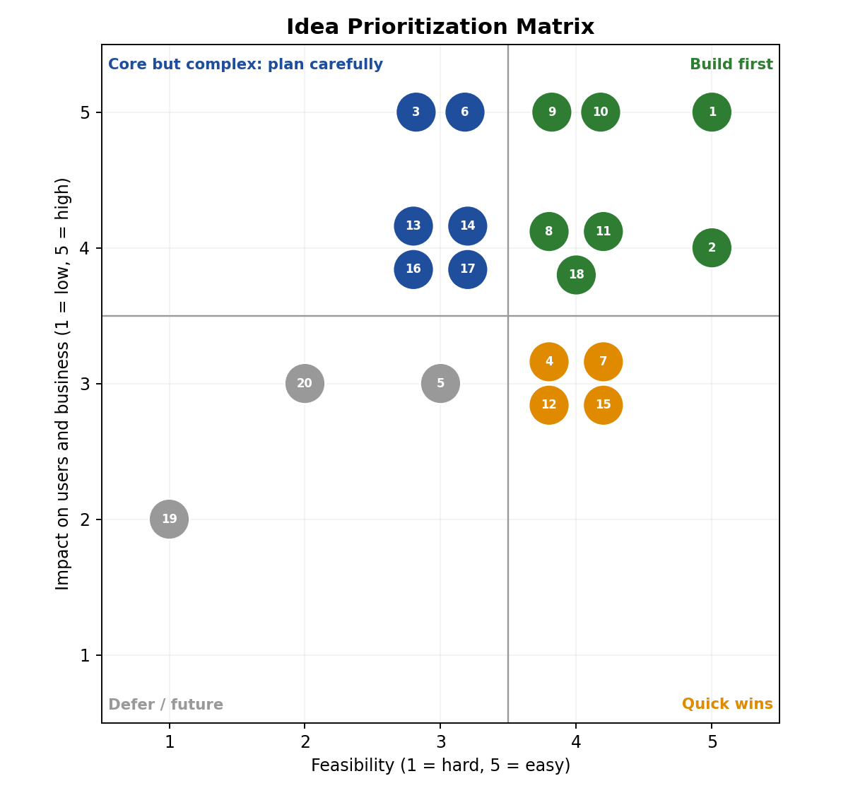
Prioritized idea list (sorted by score):
ID | Idea | Impact | Feasibility | Score | Quadrant | Decision
#1 | City-based search with auto-complete | 5 | 5 | 25 | Build first | MVP - Sprint 2
#2 | Filters by language, genre, format | 4 | 5 | 20 | Build first | MVP - Sprint 2
#9 | Mock payment gateway with retry | 5 | 4 | 20 | Build first | MVP - Sprint 4
#10 | QR e-ticket with PDF download | 5 | 4 | 20 | Build first | MVP - Sprint 4
#8 | Coupons and offers | 4 | 4 | 16 | Build first | MVP - Sprint 4
#11 | Show scheduling with overlap check | 4 | 4 | 16 | Build first | MVP - Sprint 3
#18 | Email and in-app notifications | 4 | 4 | 16 | Build first | MVP - Sprint 5
#3 | Interactive seat map, live availability | 5 | 3 | 15 | Core but complex | MVP - Sprint 3
#6 | Seat lock with 10-min timer | 5 | 3 | 15 | Core but complex | MVP - Sprint 3
#4 | Trailer, cast and reviews on movie page | 3 | 4 | 12 | Quick win | Include - Sprint 2
#7 | Food and beverage add-on | 3 | 4 | 12 | Quick win | Include - Sprint 4
#12 | Live occupancy per show | 3 | 4 | 12 | Quick win | Include - Sprint 3
#13 | Event ticket categories + capacity control | 4 | 3 | 12 | Core but complex | MVP - Sprint 5
#14 | Organizer sales dashboard | 4 | 3 | 12 | Core but complex | MVP - Sprint 5
#15 | QR scan verification for staff | 3 | 4 | 12 | Quick win | Include - Sprint 6
#16 | Admin dashboard and revenue analytics | 4 | 3 | 12 | Core but complex | MVP - Sprint 6
#17 | Cancellation with tiered refunds | 4 | 3 | 12 | Core but complex | MVP - Sprint 5
#5 | Personalised recommendations | 3 | 3 | 9 | Defer / future | Basic popularity version - Sprint 6
#20 | Loyalty points and wallet | 3 | 2 | 6 | Defer / future | Future enhancement
#19 | AI chatbot for booking help | 2 | 1 | 2 | Defer / future | Future enhancement
Conclusion:
- Ideas in the Build first and Core but complex quadrants form the minimum viable product: search and filters, seat map and seat locking, coupons, mock payment, QR tickets, show scheduling, events, refunds, notifications and the admin dashboard.
- Quick wins (trailer and reviews, food and beverages, occupancy view, QR scan verification) are added when sprint capacity allows.
- Recommendations start as a basic popularity-based version; the AI chatbot and loyalty wallet are recorded as future enhancements, as listed in the SRS.
- Core but complex ideas, especially seat locking and capacity control, receive early testing because they carry the highest risk of double booking.

